Assignment 1:Create a Simple Q&A Chain
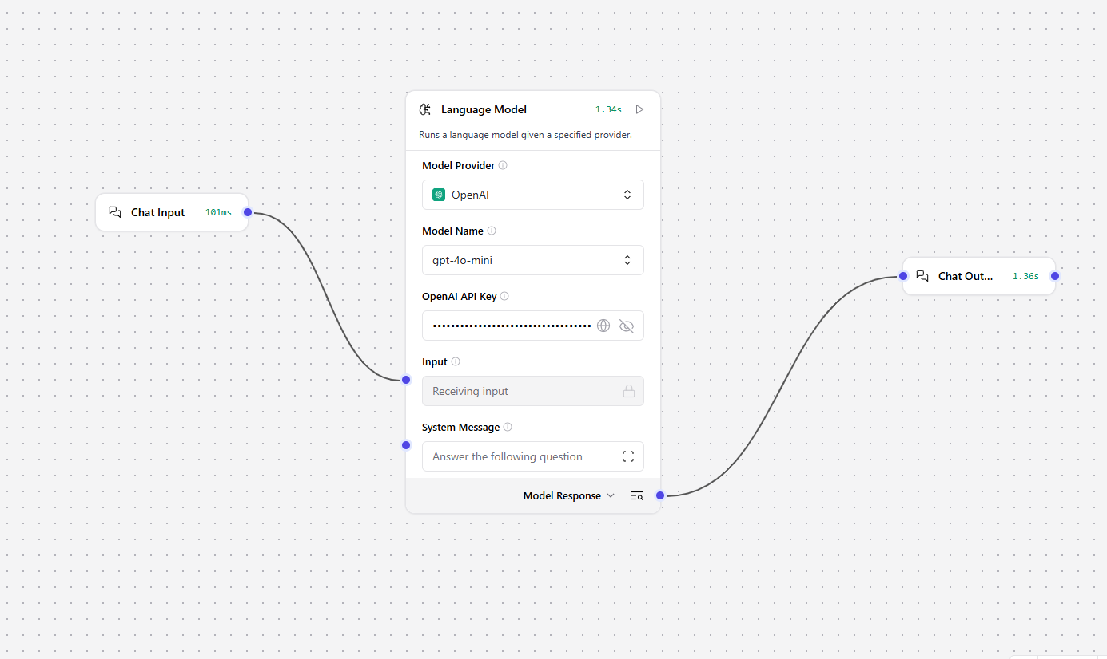



Assignment 2: Add a Retriever for Document Q&A

My URL: https://en.wikipedia.org/wiki/Skateboarding
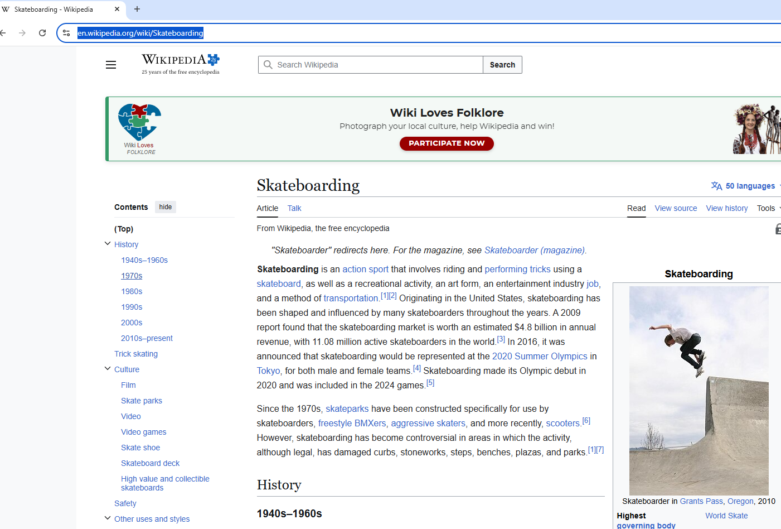
Connect the URL to the agent by using the tool mode
With Tool Mode ON:
- The Agent becomes a “thinking” agent
- It can choose to call the URL tool
- It can decide how to use the scraped content
- It can combine your question + the scraped data
- It can produce a grounded answer

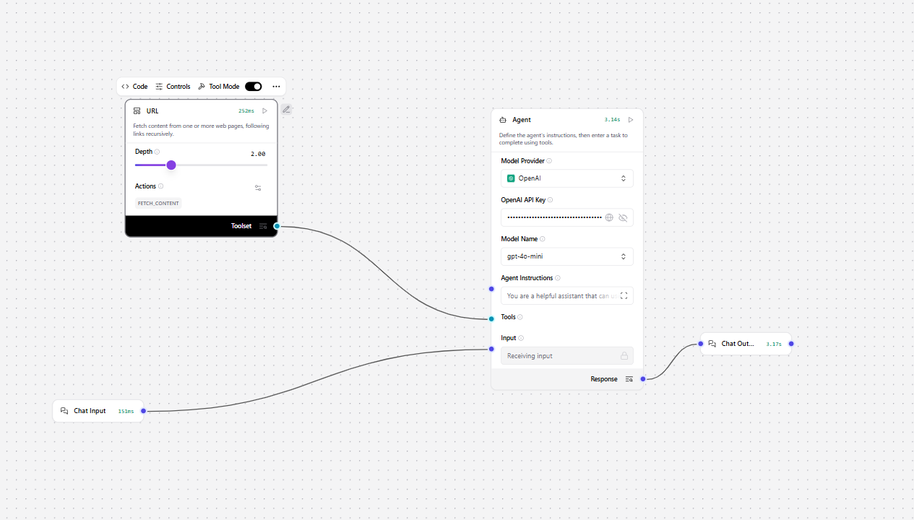

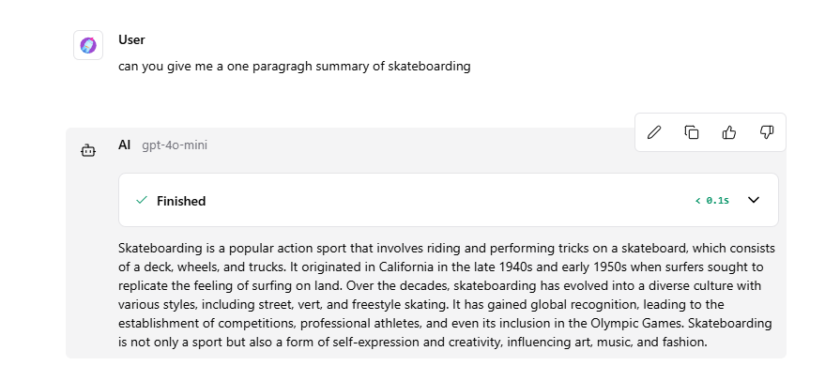

Assignment 3: Use a Tool in an Agent
My url from yahoo finance:

Here is my flow
“If a stock grows at an average monthly rate of 3.2%, what would a $7,500 investment be worth after 18 months? Show every step of the calculation.”
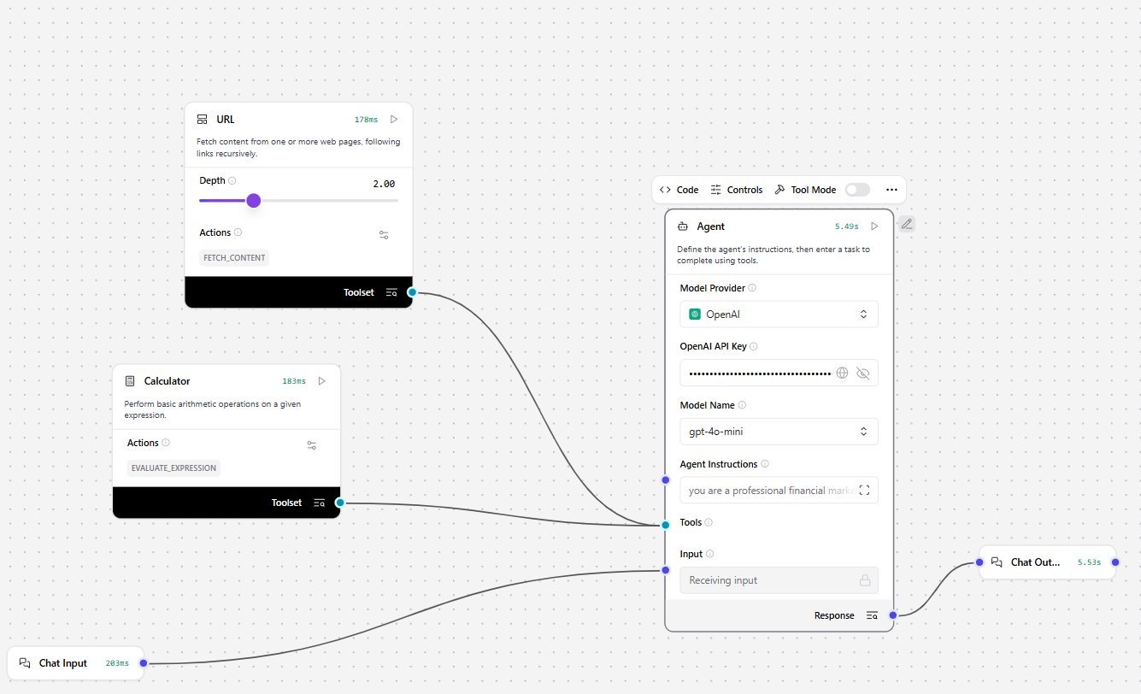
My prompt in playground:
“If a stock grows at an average monthly rate of 3.2%, what would a $7,500 investment be worth after 18 months? Show every step of the calculation.”
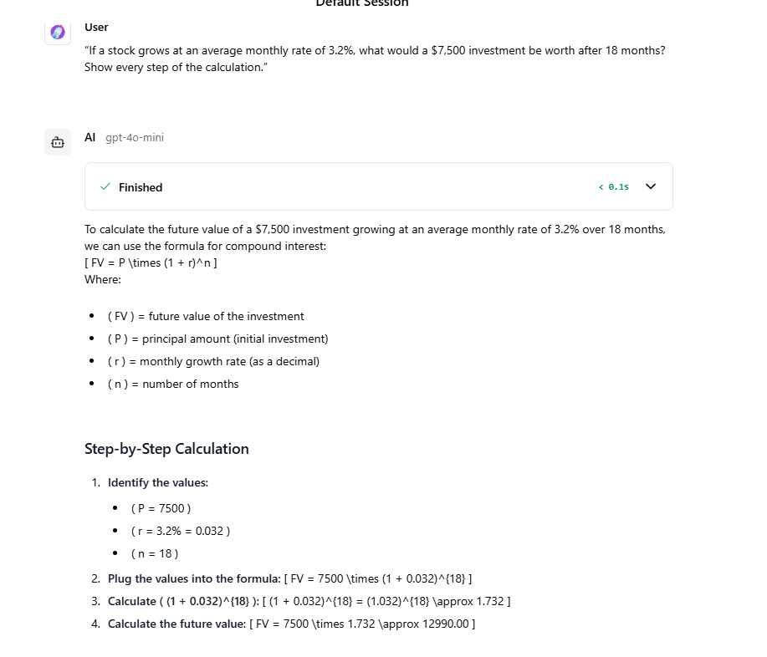
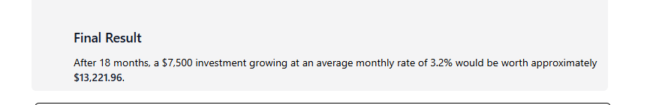
Assignment 4: Build a Multi-Input Chain

